**Console App.**

Write your own console application to perform a search in the selected directory.

The console application must support parameters from the console (as it is called)

The application writes any found files to the console and to a separate file on disk.

When the application is started it must provide the user with interactive support regarding what, where, and how to save the results.

Interaction should occur in the following manner:

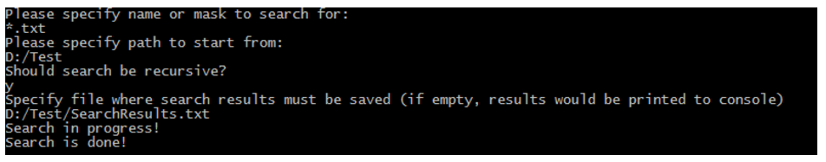

The same results can be achieved by calling SearcApp from the console:

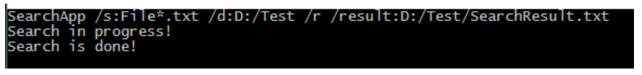

Please make sure the app supports Cyrillic and spaces in params and in the search path.

As a sub task to consider:

Can you provide a way to stop a search

Please follow a coding style and best practices.

[1] - C# 4.0 - The Complete Reference - Herbert Schildt. Page 35